Problem - 9

Overall Data :
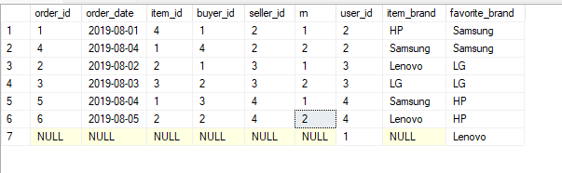

First Filter then Joining
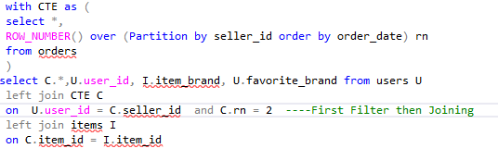
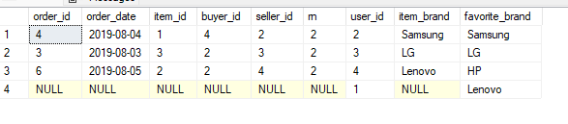

First Joining then Filter
